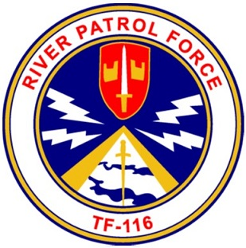

Membership Application
Gamewardens of Vietnam Assoc. Inc.
To qualify for Full Membership, you would have to been in Task Force 115,116 and 117 or in support of Task Forces afore mentioned. Army or Navy in Vietnam, or in support of Riverine Operations in any event subsequent to Vietnam. This includes today’s current array of Army and Navy boat units (Riverine , Coastal River Squadron or Special Boat Unit).
If you have left or still in service, Regular or Reserve military service a copy of your DD214 or sponsorship by an active member of Gamewardens of Vietnam Association is required. Black out your SSN before sending.
Associate Membership is open to all. Along with this membership will be an Orientation Ride and you will be able to attend all of our events and meetings.
Please circle the Chapter that you wish to be affiliated with:
West Coast | North East | South East | Mid-Atlantic | North West | Member at large (National)
PERSONAL INFORMATION: (This information will never be released to anyone!)
Last Name_____________________________ First Name________________________
Middle Name or Initial _________________
Address ____________________________________________City_________________
State _________ZIP__________
Home phone number____________________ Cell Number______________________
Email address____________________________________________________________
Spouse's Name___________________________________________________________
Sponsor's Name___________________________________Tel. _____________________

MILITARY SERVICE:
Last Unit Assignment _____________________________ No. of O/S Tours _______
Years Service ____________ Last Theater Of Operation _______________________
NIOTC Training Class ___________________________ When? Mo./Yr.___________
Pay Grade / Rate _______________, Supported Riverine Units, Yes / No Year____
If still active, present command_____________________________________________
Retired______________ From to (Mo./YR.)___________________________________
DECORATIONS:
Navy Cross____ Purple Heart_____Silver Star____ Bronze Star____ Combat Action____ PUC____ NUC___ MUC___ Nat Def____ Iraqi Campaign_____ Vietnam Campaign____ Gulf War One____ Enduring Freedom _____ Global War Terrorism ____
Badges / Other Decorations___________________________________________
_________________________________________________________________
Searching for a former “Shipmate”
Name:___________________________________________________________
TYPE OF MEMBERSHIP:
New_____ Renewal _____

Life+=$225.00 ______ Reg.Life=$200.00 _______, Bi-Annual =$50.00 _______
Annual Associate=$40.00_______ Life Associate Member= $200 _______
AMOUNT ENCLOSED $____________ Cash__ Check__ Other __ (Check One)
Received by _________________________________ Cash ______________
Date _______________ Check Number___________________
Mail to: Gamewardens Association, NW Chapter
PO BOX 970
Sumner, WA. 98390

