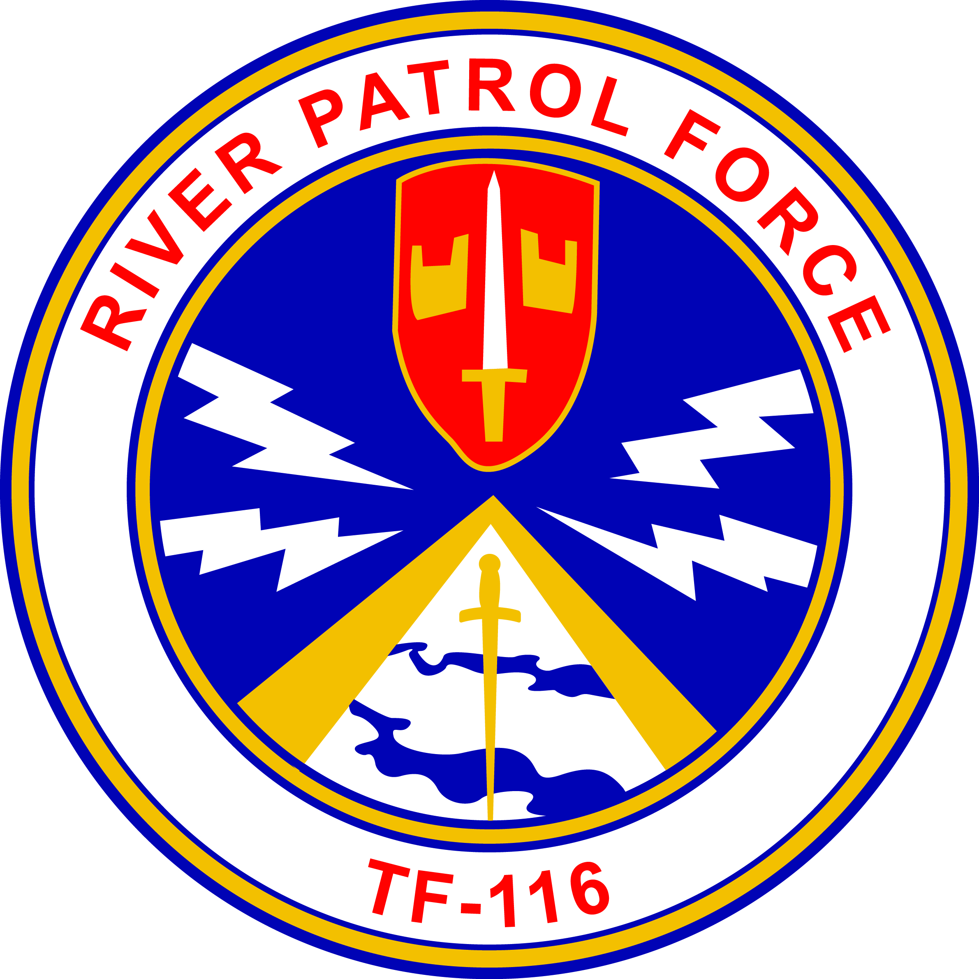
Gamewardens Association
Vietnam to Present
Formed December 18, 1968
(DBA)
Gamewardens – North West Chapter
Formed September 2005
A not for profit 501-C-19 Veterans Association

Rat’s nest Location: 1595 N. National Ave, Chehalis, WA. 98532
After Action Report (No Mail delivery)
For June 15th, and 16th , 2019, Olympic Air Show.
Submitted this date June 20th , 2019

Ahoy River Rats and Friends !

Your Hot News from the NW:
This last weekend was spent with the OP boat in static display at the Olympic Air Show. Friday
morning Pete led the procession of our utility trailer while Jamie Welsh drove the 5ton with the PBR in tow from the Rat’s Nest. I followed with the Hydraulic stairs and we spotted our equipment in the display area and secured. Bruce was rear security for the column. Peter Lahmann provided most of the pictures for the After Action Report. The waiting line to see our PBR was constant both days.
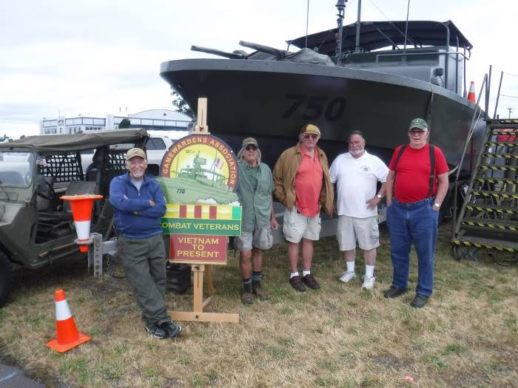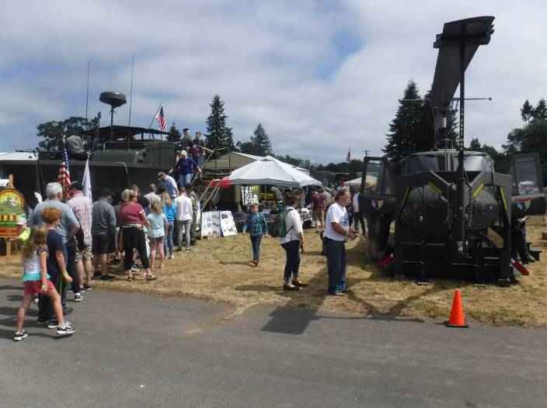
The Friday set-up crew: Bob, Bruce, Gary, Steve and Bill. The long line to see the Boat both Saturday and Sunday!
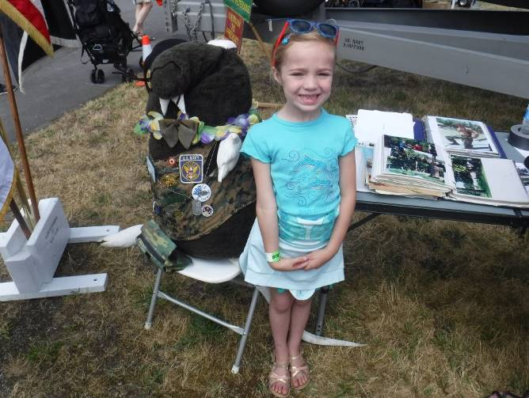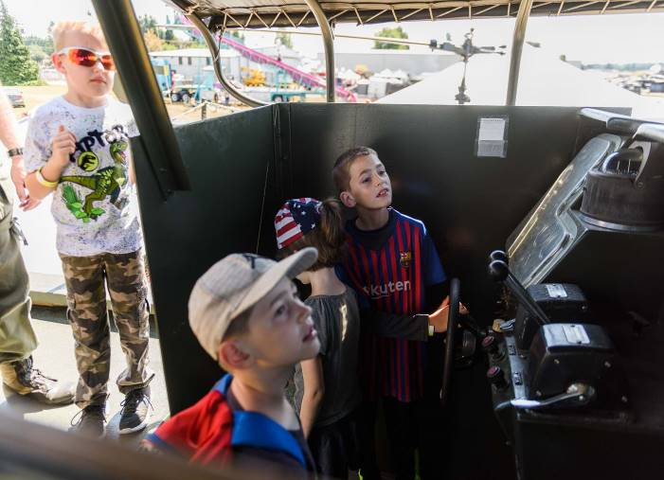
A. Billy Rat was a hit with the youngsters as usual. New boat captains in training!
The public appreciated the window into the past thru the review of Wayne Palmer’s and my picture albums. They were able to see the great sacrifices that too many of our shipmates made those many years ago.

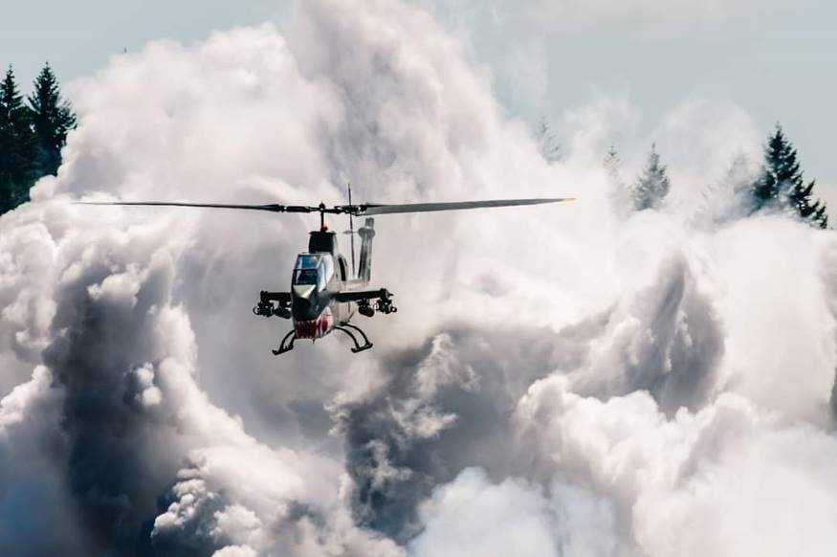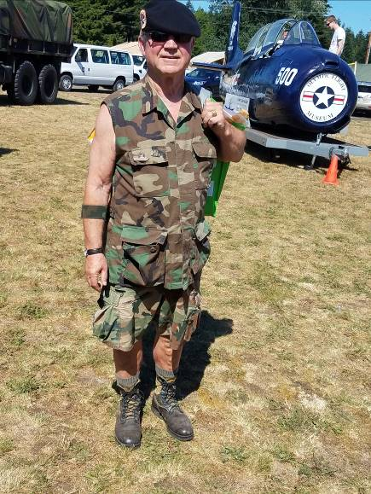
Here is a fantastic shot of the Cobra making a firing run at the Wayne Palmer is in his designer
air show by Andre Moreno! summer greens!
Manning the display for Saturday and Sunday were: Steve Morrison, Bill Gifford, Ward “Bern” Smith, Gary Larson, Jamie Welsh, Wayne Palmer, Al and Jeanene Stephens, Richard Linn and I. We hosted hundreds of the public wanting to have a better understanding of our Vietnam experience and many supported our efforts by donating to our boat fund. Many hats and t-shirts were sold. If you have not ever attended the Airshow I highly recommend it. You don’t get to see a jet car win a race against a cobra helo every day.
Through the hard work of those chapter members attending and providing oral histories, the chapter earned a bit more than $1900.00 in sales and donations for our general fund. Well done guys!!

Coming Attractions!!

- 4th of July !!
- Centralia (Static Display) and Parade & (Pete’s Famous BBQ luncheon)-Wed, July 4th

We are planning again this year to attend the Centralia military display at Fort Borst Park just
a half block west of exit 82 of the I-5 freeway. We will attend the free breakfast there at 8:00am Saturday morning after moving the OP boat and hydraulic stairs from the Rat’s nest at 7:30. At 12:00 we will move the boat to the parade staging area between the 400 and 600 block of Centralia College Blvd. There is parking at that location. Those that want to ride the boat in the parade can meet at that location. We have been invited to Pete’s famous BBQ at his home ( 311 N. Iron St., Centralia ) The parade starts a 4:00pm. After the parade we will drop off at the staging area for your cars. The boat and stairs will be taken back to the rat’s nest at that time. Everyone will have time to get to the best fireworks shows for the evening.
So far I have attending: Steve Morrison, Heinz Hickethier, Ward “Bern” Smith, Bob Brower, Wayne Palmer, Eryk Maroon and one or two of his active buddies and myself. This will be Eryk’s first opportunity to proudly wear his new black beret. Jamie Welsh is our confirmed driver.
- Des Moinses Keels and Wheels!! July 20th and 21st
We will move the boat to Des Moines on Friday and have the boat lift put the boat into the water!
We will have our ships store available to the public and do mini patrols for the weekend. We will use this opportunity to train more boat captains. Bruce is working on a Boat captain’s manual for this purpose.

Chapter annual calendar is attached!
Be sure and make note of the summer activities on the new calendar and mark you
vacations accordingly.

Chapter Finances!
With monies earned from the Olympic Air Show and your donations our budget is stable at present. Thanks guys for your financial support to keep us afloat.

This next month!
- The Fort Lewis Museum Multi era Historical Event @ JBLM Museum – Friday, August 2nd thru the 4th^{th} More details for this activity to come!

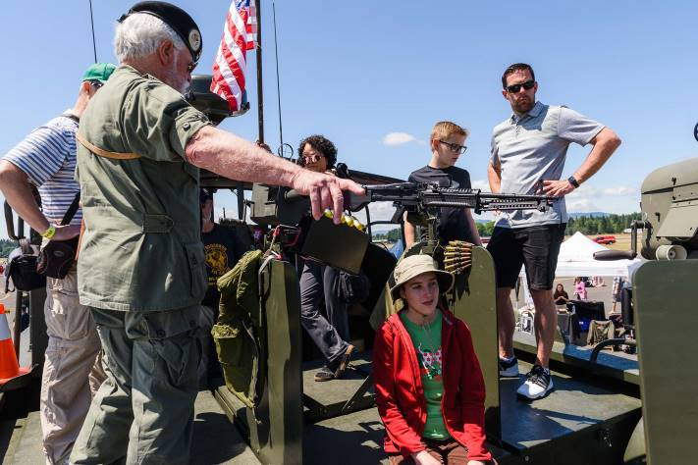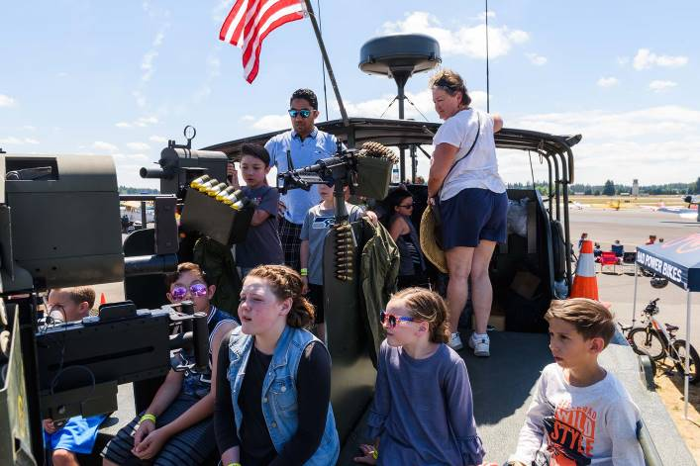
Steve Morrison teaching Vietnam History on the stern of PBR750
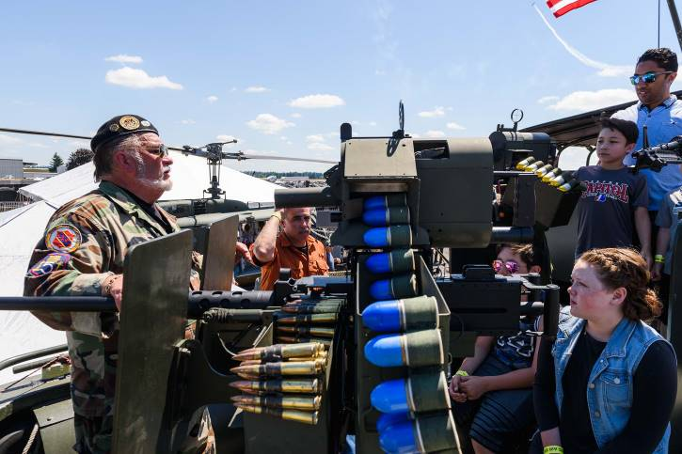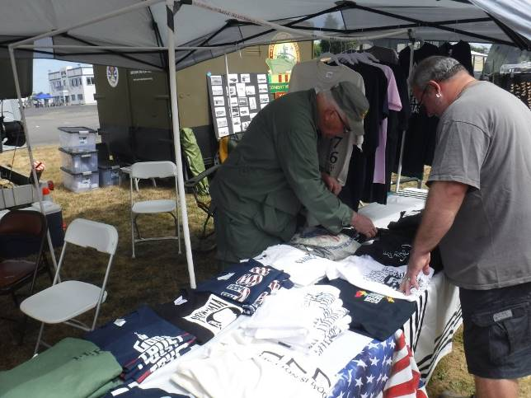
Yours truly losing my voice doing oral histories. Captain “Bern” Smith doing his thing with the ships stores.

Take care and will see you soon,
Your leadership, Steve, Peter and Bob

